1. Add a date field in the existing table. Search the records where date is in current year

select * from employee where date_part('year',date)=date_part('year',CURRENT_DATE);

2. Fetch the quarter of the date field for all the records.

select extract (quarter from date),date from employee;

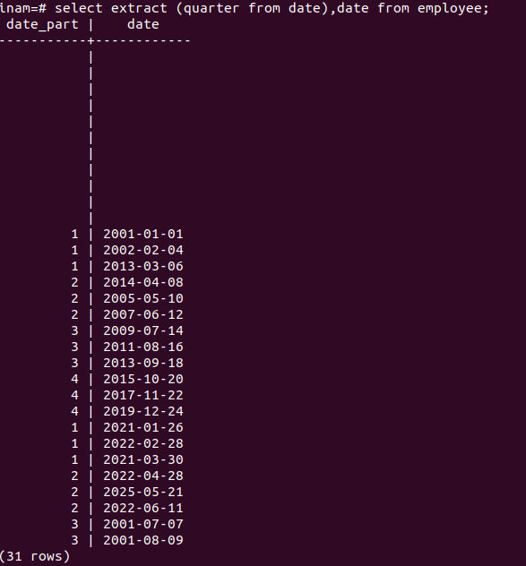

3. Fetch the year of the date field for all the records.

select extract (year from date),date from employee;
date_part | date
-----------+------------
|
|
|
|
|
|
|
|
|
|
|
2001 | 2001-01-01
2002 | 2002-02-04
2013 | 2013-03-06
2014 | 2014-04-08
2005 | 2005-05-10
2007 | 2007-06-12
2009 | 2009-07-14
2011 | 2011-08-16
2013 | 2013-09-18
2015 | 2015-10-20
2017 | 2017-11-22
2019 | 2019-12-24
2021 | 2021-01-26
2022 | 2022-02-28
2021 | 2021-03-30
2022 | 2022-04-28
2025 | 2025-05-21
2022 | 2022-06-11
2001 | 2001-07-07
2001 | 2001-08-09
(31 rows)

4. Fetch the weekday of the date field for all the records.

select extract (dow from date),date from employee;
date_part | date
-----------+------------
|
|
|
|
|
|
|
|
|
|
|
1 | 2001-01-01
1 | 2002-02-04
3 | 2013-03-06
2 | 2014-04-08
2 | 2005-05-10
2 | 2007-06-12
2 | 2009-07-14
2 | 2011-08-16
3 | 2013-09-18
2 | 2015-10-20
3 | 2017-11-22
2 | 2019-12-24
2 | 2021-01-26
1 | 2022-02-28
2 | 2021-03-30
4 | 2022-04-28
3 | 2025-05-21
6 | 2022-06-11
6 | 2001-07-07
4 | 2001-08-09
(31 rows)

5. For all the records fetch whether it’s a new admission or old admission. If the date
is of current year it will be a new admission else it will be an old admission.
Display, id, name and new/old admission. NOTE: Admission field not to be added
in the table.

select id,name,date,case when date_part('year',date)=date_part('year',current_date) then 'New addmission' else 'old addmision' end from employee;

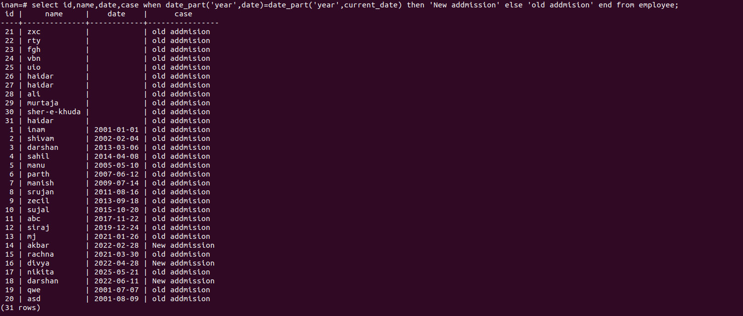

6. Add a primary key to the table as id.

alter table employee add primary key(id);
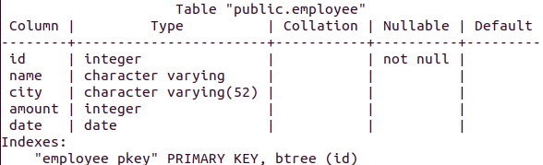

7. Create two tables one will be employee and another will be city. Add a primary
key id in both the tables. Add a foreign key of city in the employee table as
city_id.

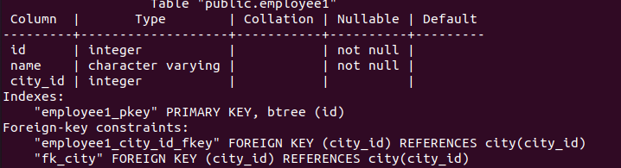

8. Add a not null constraint for name field in employee.

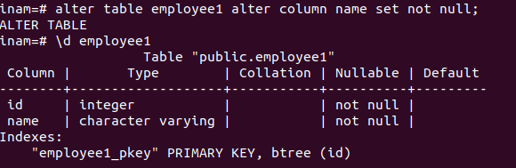
In this primary key have already not null constraint and we also add name is not null.

9. Add a new field in Code in the city table. Add a unique constraint on the code
field.

alter table city add column code int;
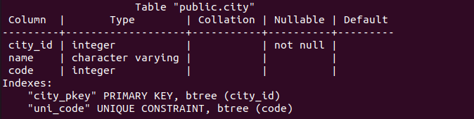

10. Add another table called Company and a primary key as id. Now add a foreign
key of company in city table. Add a unique constraint with combination of
company and code fields. Remove the old unique constraint with only code field.

11.Check that the date is not before 2010-01-01 in the employee table using check
constraint.

alter table employee add constraint checkdate CHECK (date > '1999-01-01');
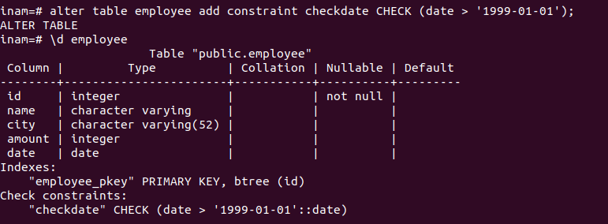
12. Create an index on the name field in City Table.
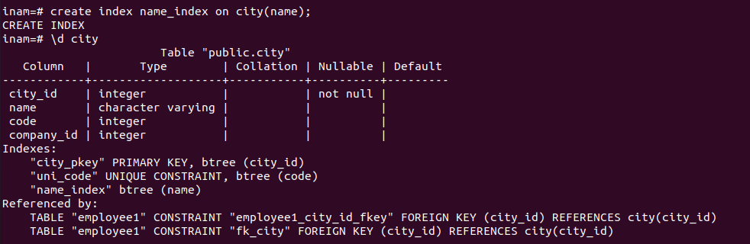
13. Create an index on the date and city fields in Employee Table.

create index ct_dt on employee(city,date);

Table "public.employee"
Column | Type | Collation | Nullable | Default
--------+-----------------------+-----------+----------+---------
id | integer | | not null |
name | character varying | | |
city | character varying(52) | | |
amount | integer | | |
date | date | | |
Indexes:
"employee_pkey" PRIMARY KEY, btree (id)
"ct_dt" btree (city, date)
Check constraints:
"checkdate" CHECK (date > '1999-01-01'::date)

14. Create an index on the name field in Employee table.

create index name_ind on employee(name);

Table "public.employee"
Column | Type | Collation | Nullable | Default
--------+-----------------------+-----------+----------+---------
id | integer | | not null |
name | character varying | | |
city | character varying(52) | | |
amount | integer | | |
date | date | | |
Indexes:
"employee_pkey" PRIMARY KEY, btree (id)
"ct_dt" btree (city, date)
"name_ind" btree (name)
Check constraints:
"checkdate" CHECK (date > '1999-01-01'::date)

15. Create an index on the name field in Company table. Remove the index.
--->create index cpm_index on company (com_name);

Table "public.company"
Column | Type | Collation | Nullable | Default
----------+-----------------------+-----------+----------+-------------------------------------
id | integer | | not null | nextval('company_id_seq'::regclass)
com_name | character varying(64) | | |
Indexes:
"company_pkey" PRIMARY KEY, btree (id)
"cpm_index" btree (com_name)

-->-drop index cpm_index;
16. Create a primary key in a new table where there is an auto generated number
starting from 1 without creating a sequence.
--->create table student (id serial primary key,name varchar);
---->insert into student (name) values ('inam');

inam=# select * from student;
id | name
----+------
1 | inam
(1 row)

17. Create a sequence starting from 1000. Create a primary key in a new table. When
inserting records use this sequence.

--->create sequence number_seq start 1000 increment 1;

--->create table student1(id serial primary key,name varchar(64));

--->insert into student1 (id,name) values (nextval('number_seq'),'sivam');
id | name
------+-------
1000 | sivam
(1 row)
--->insert into student1 (id,name) values (nextval('number_seq'),'anup');
id | name
------+-------
1000 | sivam
1001 | anup
(2 rows)

18. Create a sequence starting from 500. Create a primary key in a new table and
assign default value from this sequence.

--->create sequence que_18 start 500;
--> create table student2(id serial primary key,name varchar(64));
--> alter table student2 alter column id set default nextval('que_18');
--> insert into student2(id,name) values (nextval('que_18'),'raju');
--> insert into student2(id,name) values (default,’rajan’);

inam=# select * from student2;
id | name
-----+------
500 | raju
501 | inam
(2 rows)

19. Delete the sequence which was created with 1000. Try to use the sequence to
insert records.
--> drop sequence que_18;
inam=# insert into student1(id,name) values (nextval('que_18'),'raju');
ERROR: relation "que_18" does not exist

20. Create a sequence for an existing table and assign it in the default value.

inam=# create sequence id_seq increment 1 start 17;
CREATE SEQUENCE
inam=# alter table company alter column id set default nextval('id_seq');
ALTER TABLE
inam=# insert into company(com_name) values ('skyscend');
INSERT 0 1
inam=# select * from company;
id | com_name
----+----------
17 | skyscend
(1 row)

21. Create a new table add a field with default value.

--> create table student3(id int,name varchar(64));
--> alter table student3 alter column id set default 0;
--> insert into student3(id,name) values (default,'sajid');
--> select * from student3;
id | name
----+-------
0 | sajid
(1 row)

22. Add a gender field in Employee table which accepts only values male and female.
It must not be NULL. Perform this action without using a check or foreign key
constraint. However you can use other constraints.

--->create type inam_demo as ENUM ('male', 'female');
--->alter table employee add column gender inam_demo;
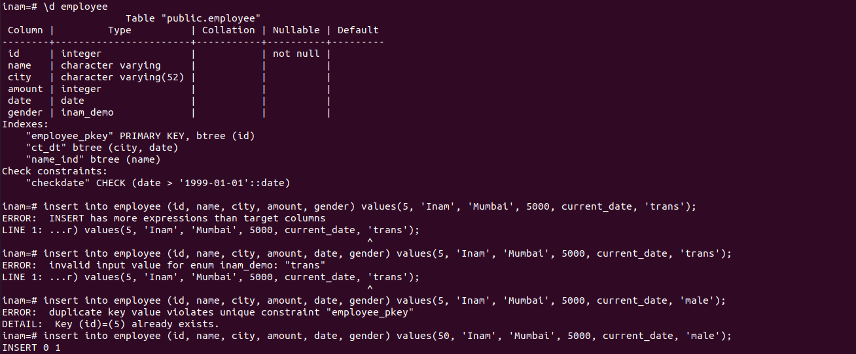

23. Display the fields id, name, city name from employee and city tables using inner
join and aliases.

-->select emp.emp_id,emp.name,ct.city_name from employee emp INNER JOIN city ct on emp.emp_id=ct.id;

24. Display id, name, city name and company name from employee, city and
company tables.

select emp.id,emp.name,ct.name,cp.com_name from emp emp inner join city ct on emp.id=ct.company_id inner JOIN company cp on emp.id=cp.id;

id | name | name | com_name
----+-------+-------------+-----------
17 | inam | Ahemdabad | skyscend
18 | sivam | Gandhinagar | techultra
19 | sahil | Anand | infosys
20 | manu | Surat | wipro
(4 rows)

25. Update records using a subquery.

UPDATE employee SET name=subquery.name,city=subquery.city from (select name,city from employee) AS subquery WHERE employee.city =subquery.city;

26.Create a view using the above select query result.
create view employee_info as (select emp.id,ep.name,emp.city,emp.amount,emp.date from employee emp INNER JOIN emp1 ep on emp.name=ep.name);

27.Delete the view and create a new view adding fields as id, name, amount, date,
city name , city code and company name.
drop view employee_info;

28. Insert 15 records using an sql file. In the same file update 5 records of the city
Mumbai increase the amount with 10.

psql -d inam -f city.sql;
inam=# select * from employee2;
id | city | amount
----+-----------+--------
1 | pune | 15000
2 | jaipur | 14000
3 | jodhpur | 17000
4 | rajpur | 14000
5 | nagpur | 19000
6 | nagalpur | 25000
7 | pune | 10000
8 | unjha | 8000
9 | vijapur | 5000
10 | visnagar | 7000
11 | manipur | 3000
12 | bhavnagar | 2000
13 | texas | 9000
14 | sydney | 28000
15 | melbourne | 12000

now update records in sql file.

inamhusain@inamhusain-HP-Laptop-15s-eq2xxx:~$ psql -d inam -f city.sql;
INSERT 0 15
UPDATE 1
UPDATE 1
UPDATE 1
UPDATE 1
UPDATE 1

inam=# select * from employee2;
id | city | amount
----+-----------+--------
1 | pune | 15000
7 | pune | 10000
8 | unjha | 8000
9 | vijapur | 5000
10 | visnagar | 7000
11 | manipur | 3000
12 | bhavnagar | 2000
13 | texas | 9000
14 | sydney | 28000
15 | melbourne | 12000
2 | mumbai | 14000
3 | mumbai | 17000
4 | mumbai | 14000
5 | mumbai | 19000
6 | mumbai | 25000
(15 rows)

29. Create a backup of the database and restore it using psql.

--> psql inam> inam_db_backup.sql
-->psql sinam -f inam_db_backup.sql

30.Create a backup of the database and restore it using pg_dump and pg_restore.
--->pg_dump -Fc inam > backup.sql
--->pg_restore -d inam sujal_1_backup.dump;

